**Name:** Madhuri Ramakrishnan **Roll No.:**119A3032 TE IT (E2)

EXPERIMENT 1

**Aim:** To create EC2 instance on AWS cloud and host a website on it.

# Theory:

**AWS**

**Amazon Web Services** (AWS) is the world’s most comprehensive and broadly adopted cloud platform, offering over 200 fully featured services from data centers globally.

AWS is made up of so many different cloud computing products and services. The highly profitable Amazon division provides servers, storage, networking, remote computing, email, mobile development, and security.

# EC2

An Amazon EC2 instance is a virtual server in Amazon's **Elastic Compute Cloud** (EC2) for running applications on the Amazon Web Services (AWS) infrastructure Amazon provides various types of

instances with different configurations of CPU, memory, storage and networking resources to suit user needs.

# Output:

**Steps to create EC2 instance and host a website:**

1. Register to AWS console.
2. Go to Services and under Compute section, select EC2.
3. 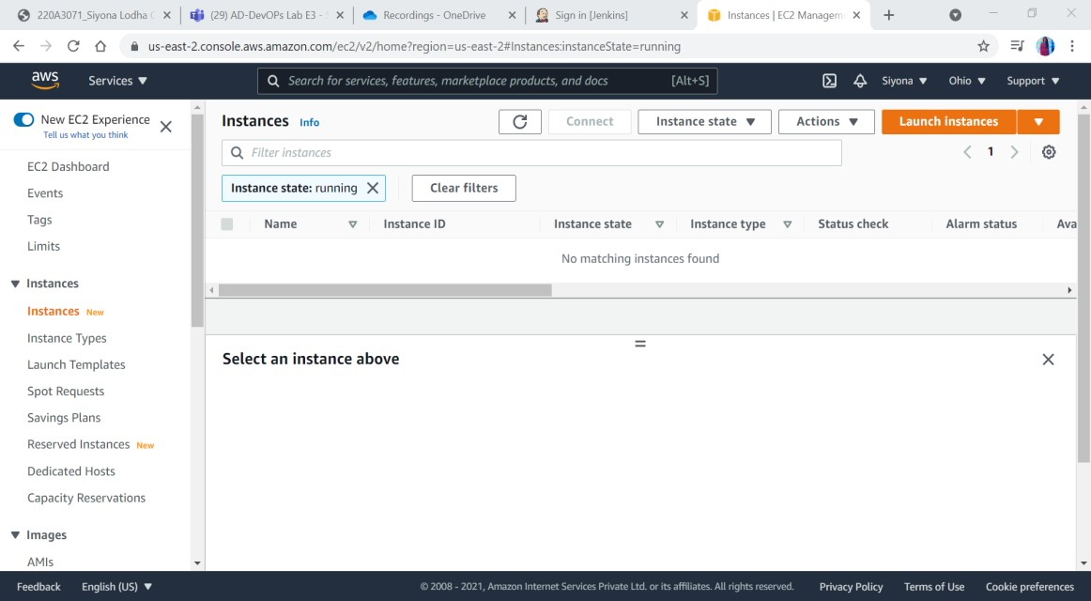Select Instances.
4. Click on Launch Instances.
5. Choose an Amazon Machine Image (AMI) as Windows 2016 base.
6. Choose an Instance Type.
7. Click on next and select the default configurations till Add Storage.
8. In Add Tags give **Key = Name** and **Value = Webserver**.
9. In Configure Security Group Add Rule as HTTP and select Source as Anywhere.
10. Click on Launch and a dialogue box will appear.
11. 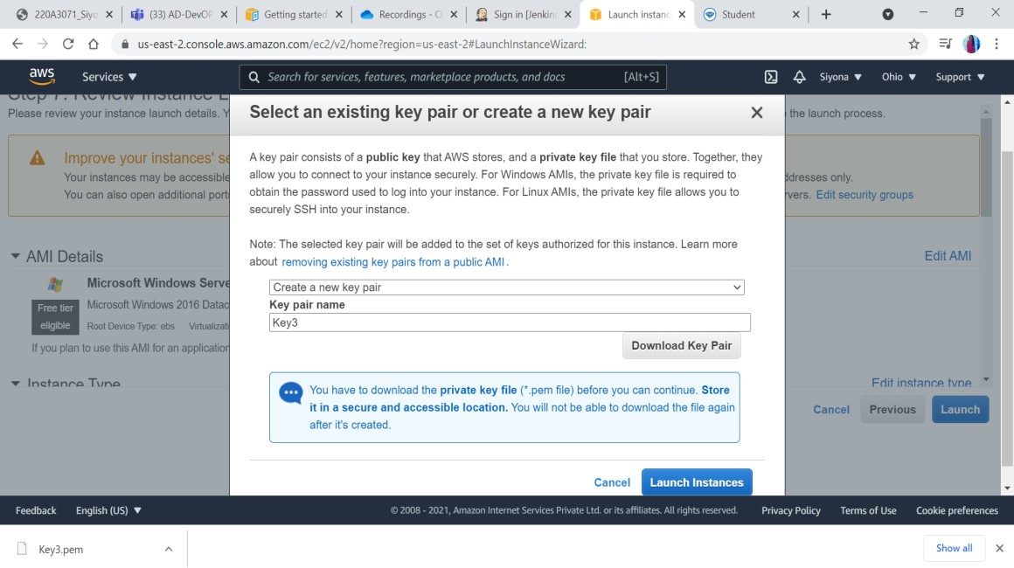Select create a new key pair and name it as Key3.
12. Download the Key pair.
13. 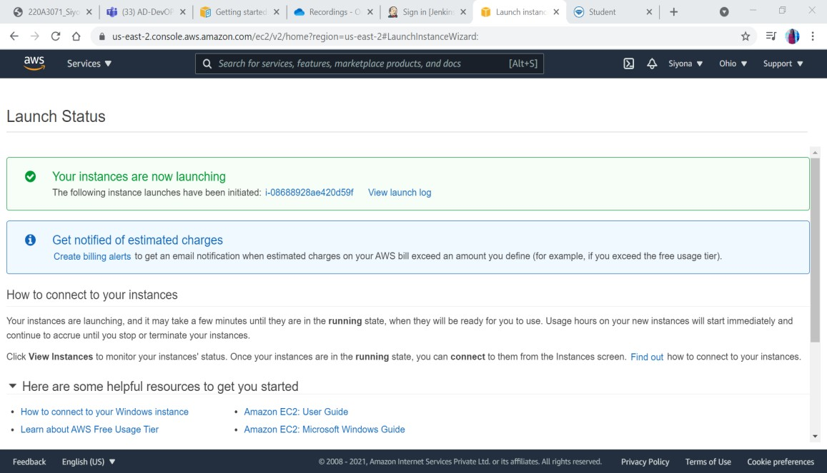Launch Instances.
14. 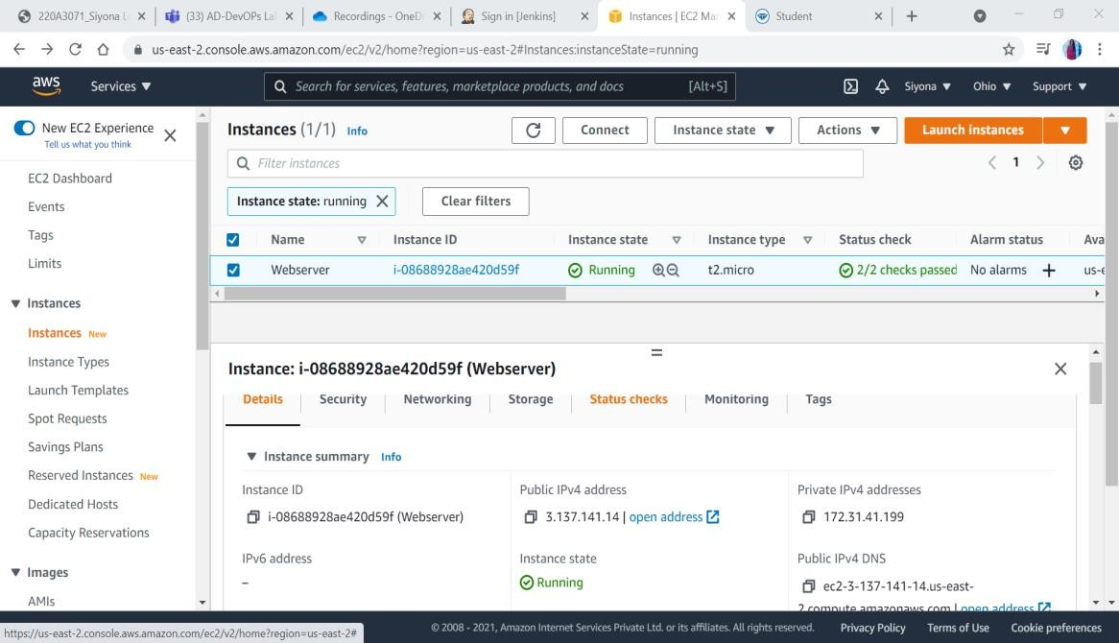On the Instances page, click on connect and under RDP client, download remote desktop file.
15. Click on get password and browse to your key pair file.
16. Copy the password and open the remote desktop file and paste it.
17. 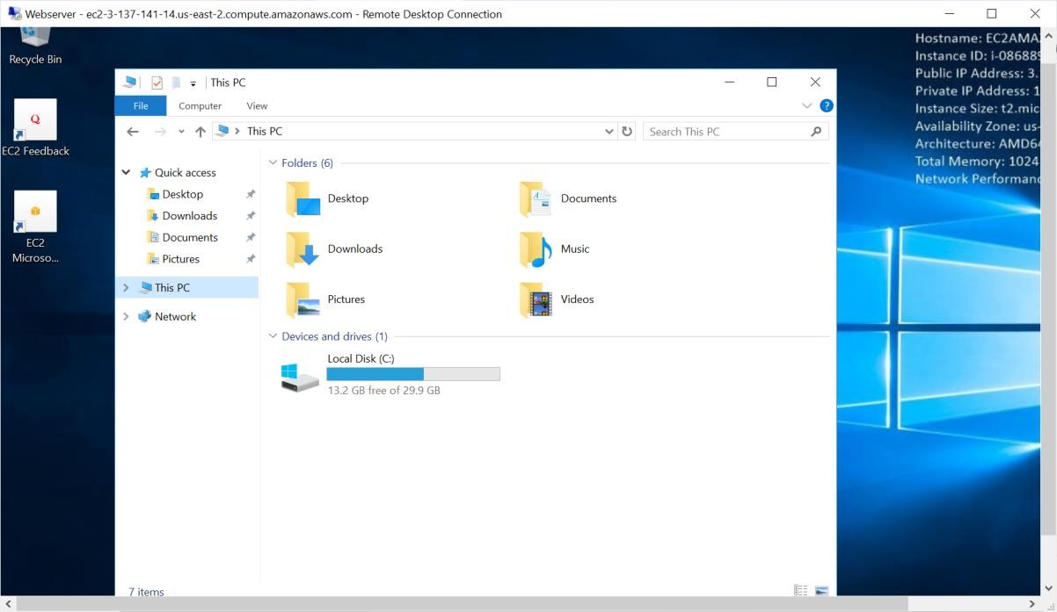It will open an AWS Infrastructure i.e Virtual machine.
18. Open Server Manager, click on Add roles and install IIS Web Server by clicking next.

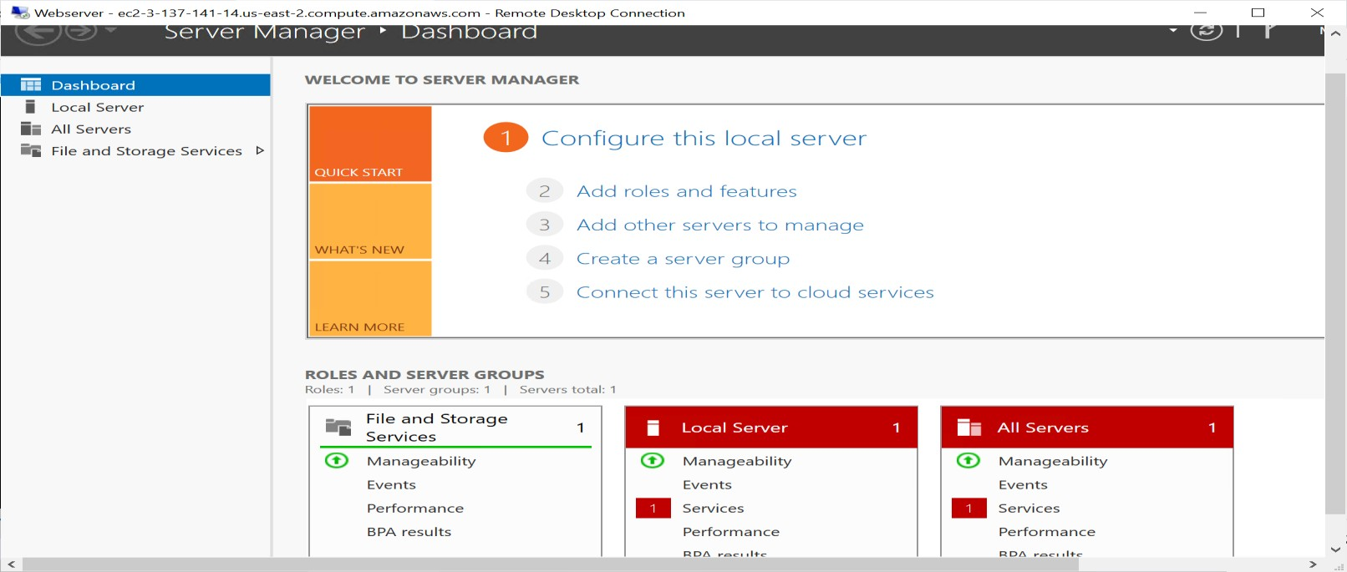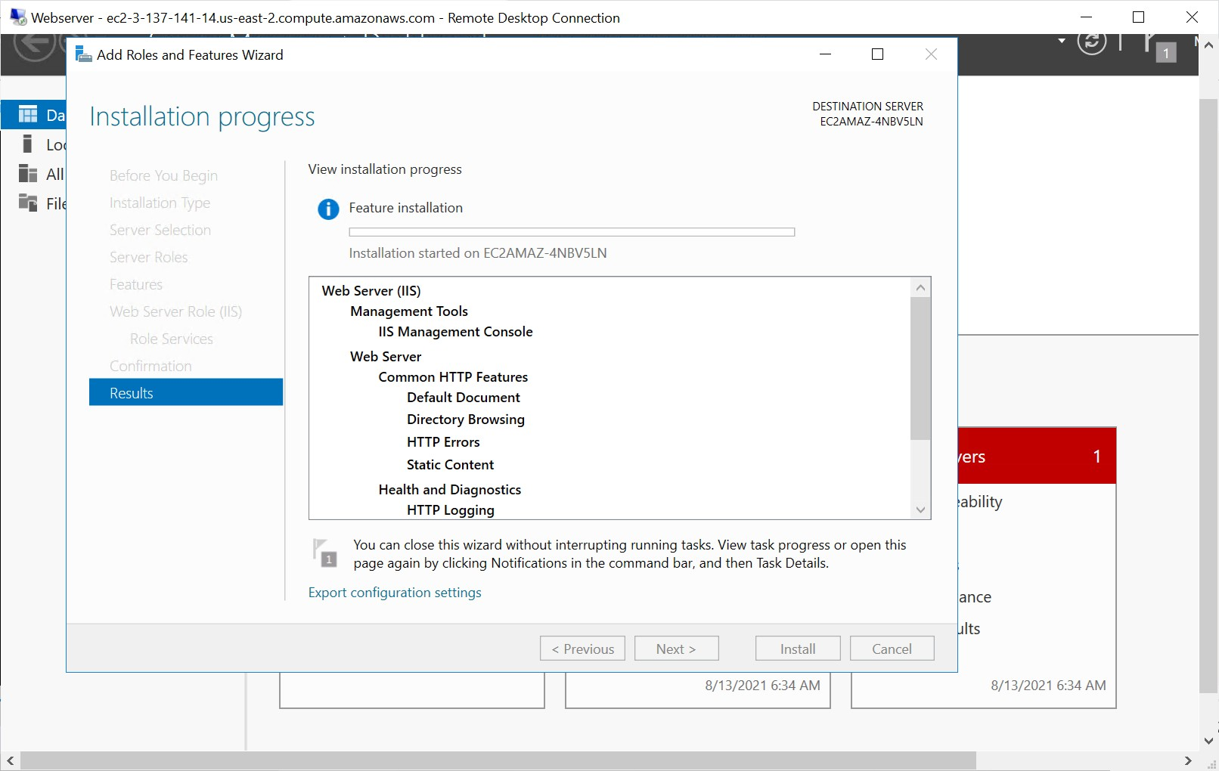

1. A folder is created in the C drive named inetpub -> wwwroot -> create index.html.

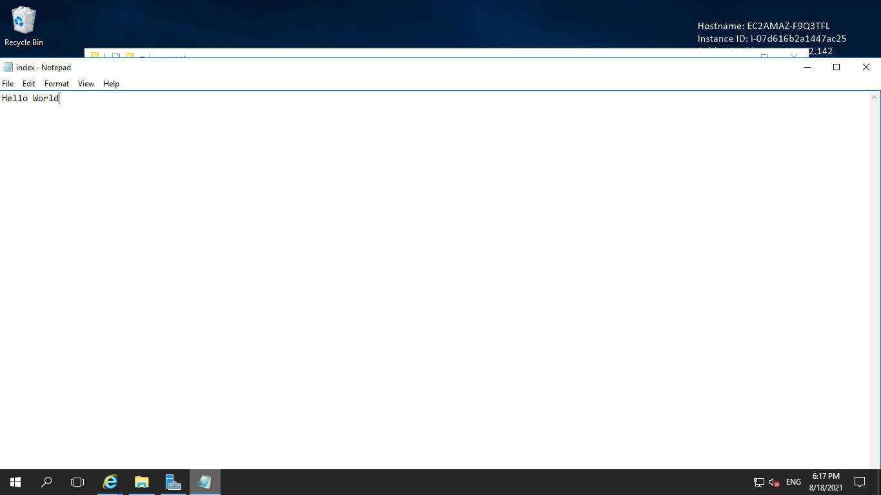

1. Copy the public IPv4 address from your AWS console and paste it in a new tab to see your website.
2. 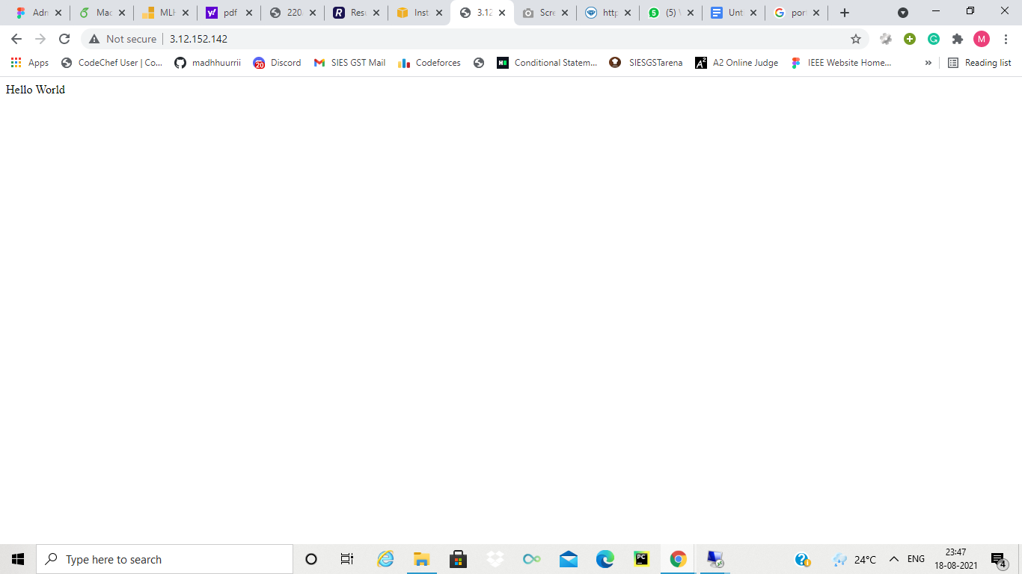Successfully the website is hosted.

**Conclusion:** Hence, we studied about how to create EC2 instances and AWS cloud and to host a website on it.